MS SQL SERVER
Standard Operating Procedures
(SOP)
SQL Server Logins
Submitted to



BY



CIS, Wipro Limited

Document Details

Project Name | Innogy SE
Account | CIS
IT Component/Application Title | SQL Server Logins
Current Version | 1.5
List of Contributors | Pradipkumar Kansara, Kiran Bhalekar, Ayushi Gautam, Sivakumar Goud, Nanda Kishore Reddy
Customer Contact Information

Version History
(All revisions made to this document must be listed in chronological order. All revisions must be approved. Review and Approval can be done by an internal source or by the customer)
Version | Date of Revision | Description | Author | Reviewed By | Approved By
1.0 | 29-08-2015 | Initial Draft | Kiran Bhalekar | Pradipkumar Kansara | Mahesh Keshatwar
1.1 | 04-09-2015 | Document Completed | Kiran Bhalekar | Pradipkumar Kansara | Mahesh Keshatwar
1.2 | 21-08-2016 | Updated document to standard format | Kiran Bhalekar | Pradipkumar Kansara | Mahesh Keshatwar
1.3 | 17-05-2017 | Wipro and Innogy Logo changed | Sivakumar Goud | Pradipkumar Kansara | Mahesh Keshatwar
1.4 | 14-09-2017 | Updated document to Wipro Standard format with header and footer | Sivakumar Goud | Pradipkumar Kansara | Santosh Badiger
1.5 | 05-12-2018 | Updated the content | Nanda Kishore Reddy | Pradipkumar Kansara | Santosh Badiger

Document Distribution List
Sl. No. | Name and Company | Purpose
1 | RWEIT-SQLDBA | Document is useful for day to day activity for creating logins.
2

Table of Contents

1. Purpose 3
2. Scope 3
3. Introduction / Overview 3
4. Process 3
5. Detailed Procedure 3
6. Tasks and Responsibilities 3
7. FAQ 3
8. Contacts 3
9. Checklist 3

Purpose
The purpose of this document is to describe the process of adding a MS SQL server login and granting the required permissions/access. This gives you an idea of steps involved in CREATING, MODIFYING and DELETING SQl server logins and granting permissions.

Scope
This document provides first hand information on how to add logins to SQL server and granting them permissions as per the requirement. This document provides step by step procedure to add a login as a ‘system admin’ (sa).

Introduction / Overview

This section contains the information / overview of the steps required to create edit and deleting logins.

Process

Flowchart of process.

Detailed Procedure
There are two types of doing this
  - Through GUI
  - Through query analyzer using T-sql commands.

Through GUI

1. Open the SQL Server Management Studio go to security select logins. Right click on logins select new login you will get this window.

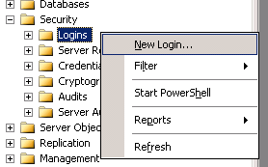

2. There are two types of logins
a. Windows Authentication
b. SQL Server Authentication
Below shows the Windows Authentication screen where we need to give name of the login and domain to which they belongs to
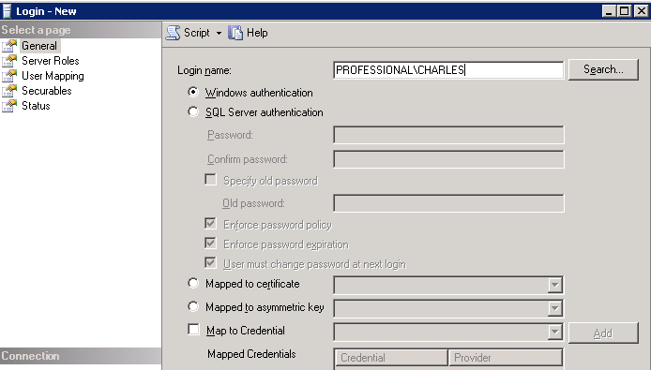

Below shows the SQL server authentication screen where you need to give the password of the concerned individual group or person separately.

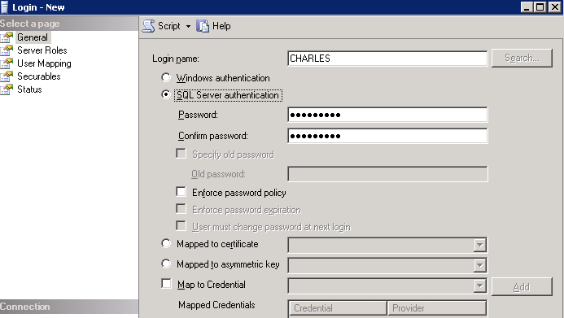

3. Server roles can be assigned by checking the required server roles as below.

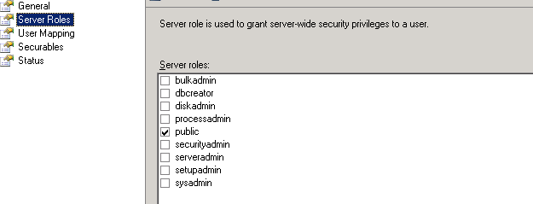
Server roles in SQL server

Fixed server role | Description
sysadmin | Performs any activity in SQL Server. The permissions of this role span all of the other fixed server roles.
serveradmin | Configures server-wide settings.
setupadmin | Adds and removes linked servers, and executes some system stored procedures, such as sp_serveroption.
securityadmin | Manages server logins.
processadmin | Manages processes running in an instance of SQL Server.
dbcreator | Creates and alters databases.
diskadmin | Manages disk files.
bulkadmin | Executes the BULK INSERT statement.

3. Below screen shot provides the type of database access to database roles with respect to the above login credentials.

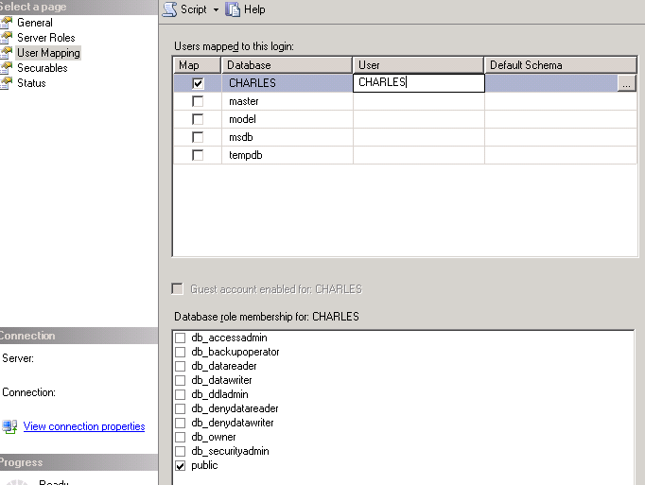

Fixed database role | Description
db_owner | Performs the activities of all database roles, as well as other maintenance and configuration activities in the database. The permissions of this role span all of the other fixed database roles.
db_accessadmin | Adds or removes Windows NT 4.0 or Windows 2000 groups and users, and SQL Server users in the database.
db_datareader | Sees all data from all user tables in the database.
db_datawriter | Adds, changes, or deletes data from all user tables in the database.
db_ddladmin | Adds, modifies, or drops objects in the database (runs all DDLs).
db_securityadmin | Manages roles and members of SQL Server 2000 database roles, and manages statement and object permissions in the database.
db_backupoperator | Has permission to back up the database.
db_denydatareader | Denies permission to select data in the database.
db_denydatawriter | Denies permission to change data in the database.

4. Deleting any login can be done as below.
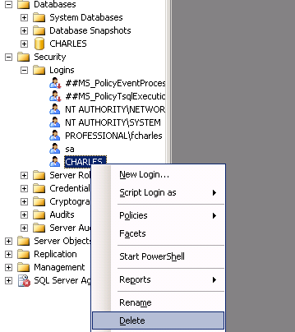

Through query analyzer using T-SQL commands.

If exists (select * from syslogins where name=' CHARLES’)
Print 'already exists'
Else
Print 'does not exists'
For windows Authentication
This example grant the windows login for user CHARLES with the domain name PROFESSIONAL

sp_grantlogin ‘PROFESSIONAL\CHARLES’
Go

To give the access to the database Nanditha_db and database role datareader below T-SQL command will help

Use CHARLES_db
Go
sp_grantdbaccess ‘PROFESSIONAL\CHARLES’
Go
sp_addrolemember 'db_datareader', ‘PROFESSIONAL\CHARLES’
Go

For SQL server Authentication
This example creates an SQL Server login for the user Nanditha, with a password of
Password, a default database of Nanditha_db, and a default language of English.
EXEC sp_addlogin ‘CHARLES’', 'Password', ‘‘CHARLES’, 'English'

To give the access to the database Nanditha_db and database role datareader below T-SQL command will help

Use CHARLES
Go
sp_grantdbaccess ‘CHARLES’
Go
sp_addrolemember 'db_datareader', ‘CHARLES’
Go

To delete login

This example removes the login ‘CHARLES’ from SQL Server.

EXEC sp_droplogin ‘CHARLES’

Tasks and Responsibilities

Tasks | Responsibilities
To Add server login | DBA
To drop user login | DBA

FAQ

Contacts

Purpose | Person
Process of adding server login | Franklin Charles

Checklist

This is primarily used to check whether we have followed all the steps

mentioned above in the process.

No | Steps
Step-1 | Confirm before giving access that login is already present in syslogins if login not found follow the below steps
Step-2 | Grant the login by giving appropriate windows or SQL server Authentication
Step-3 | After giving login permissions grant the required database access and database roles

